From the Roesse Kapoenen to the real moving thing…

Samuel Verbiese
Artist
Terholstdreef 46
B – 3090 Overijse
Belgium
E-mail: verbiese@alum.mit.edu

Abstract

This paper relates the morphing of a pipe rendering of the Roesse Kapoenen, a family of five alien characters marching foot in foot, towards incredibly vivid and suggestive humanity. A gutsy performance of artificial life…

The Roesse Kapoenen

A 3x3meter square sheet 15mm thick of Corten steel generates a family of five rusted strange folks, their name morphed from the Witte Kaproenen who saved the city of Ghent, Belgium, from middle age invaders, and the remaining part of the sheet prepares others to stand up and fight their life [1] (fig. 1).

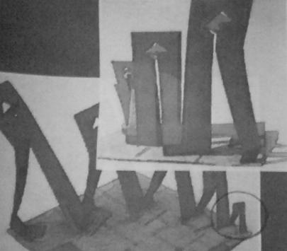

Figure 1: The Roesse Kapoenen
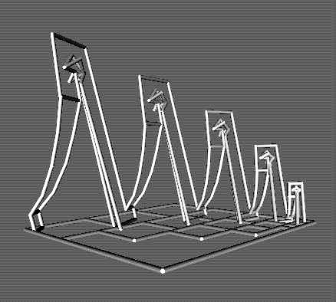

Figure 2: Pipe Roesse Kapoenen

The ludical project has been presented at a sculpture competition and exhibited with the fellow entries in front of St. Baaf’s Church in Ghent, Belgium. Now, awaiting a real life somewhere in a welcoming town, the tireless walkers get a virtual life thanks to the KnotPlot package available on Internet [2] and undergo an incredible morphing. Starting from pipes (Fig. 2), setting interactively the right parameters with trial and error, they pass through a version for kids in the tradition of the inflatable castles (fig. 3), to then gradually (Fig. 4)

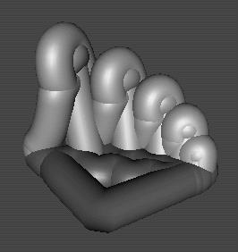

Figure 3: Roesse Kapoenen for kids
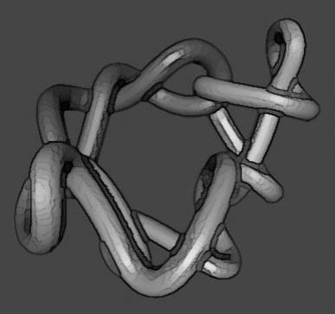

Figure 4: On their way to life…

and slowly become moving vivid guts that end up in a long chain of suggestive human members when letting serendipity perform its fate (fig. 5). The whole process will be demonstrated in real time on the computer, and Reference [1] with the original cardboard model of the Roesse Kapoenen sculpture (fig. 1) will be on display, along with others works involving the characters.

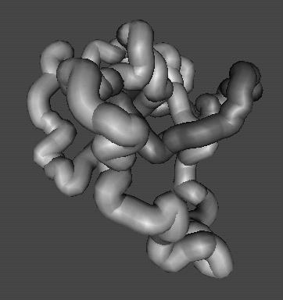

Figure 5: Life !

Acknowlegements

I like to thank Professor George W. Hart for having drawn my attention to this conference.

References

[1] S. Verbiese, De Roesse Kapoenen, Sculpture Competition 1999, Kunst in de Buurt, Ghent, Belgium.
[2] http://www.pims.math.ca/knotplot/

Copyrights

All designs are protected : Copyright ©2003 by Samuel Verbiese, Sofam-Belgium. All rights reserved.
They also respect and mention the pertaining copyrights of the used software packages.
If interested, please contact me by e-mail to address : verbiese@alum.mit.edu .

Presented as part of a poster "Tangramoids, Labyrinths, Knots and other 3-D sculptures coming unexpectedly to life with KnotPlot", at joint Isama-Bridges conference 2003, Granada, Spain, July 22-25.

Samuel Verbiese
Januari 31, 2003.

