Merging a Tibetan Endless Loop with an Ocean Plat

Samuel Verbiese
Artist
Terholstdreef 46
B – 3090 Overijse
Belgium
E-mail: verbiese@alum.mit.edu

Abstract

This paper relates the genesis of the most unpredictable knot on Earth ☺: the merging into a new knot of two distinguished yet unrelated decorative knots discovered by chance : one of the eight sacred symbols of Tibetan Buddhism, the “Endless Knot”, coming from the roof of the World, and the traditional “Ocean Plat” designed at sea level and part of world’s sailors’ knots legacy.

The Shiri Vasta…

Just before leaving back home in early 2002, my attention was caught by a series of large flags hanging in the airport of Kathmandu, Nepal. A foreign resident explained that the puzzling design represented the Endless Knot, one of the sacred symbols of the Buddhist monks from the Tibetan skies. Internet provided information and so did a book [1] I brought back. The knot, called Shiri Vasta, also Luck Knot, Live Knot and Love Knot, and which in fact reduces to a simpler one on topological grounds, is woven in a 4x4 square checker board array and displays a recurring wandering through, hence its name.

…mating with the Ocean Plat

A few months later, coming across a five lobes woven rope mat among other items on a knot board in a marine shop, and very much fond on pentagrams and Lissajous curves, I recorded the mat in my sketch book and fooled around a bit with the design to understand its construction. Yet some time later another knot board I happened to see, had French captions, except for the middle knot, again a plaited mat, a bit more complex than the other one, so it was worth coming back to the sketch book to elaborate further on this new topic. Strikingly enough anthropomorphic patterns showed up…
While doing and getting involved in generalisations, where according to certain rules the knots were single or multiple, the mat appeared to be based on a 3x3 array. So, remembering the Tibetan Endless Knot, I wondered if they couldn’t be merged, and luckily they wove quite nicely together and could even readily form a single infinite loop as well ! (Fig. 1, which represents a lithography “Anthropomorphic endless Tibetan oceanity plait[ed] around a blind Tangram”).
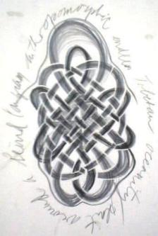

Figure 1: New Knot

Time indeed to get the name of that rope mat : Internet’s jungle might help ? It didn’t prove easy at all, as several and often contradictory if not plain wrong denominations are in use, such as Carrick Mat, Chinese Knot, Turkish Head, Ocean Plait, Napoleon Knot, Flemish Coil, Josephine, Thump in English, and baderne, paillasson in French, hence the absence of any name for this mat on the knot board, probably. Yet a wealth of information on knots and knot theory was dug out, and namely Ashley’s bible of which I got both the French translation and a reprint of the original American monument [2,3]. To discover three things : first, among his 3800 knots, Ashley didn’t apparently know the Tibetan Endless Knot; second, he provided very nice information on the “unnamed mat” (Tresse Océane in French, and Ocean Plat in English); and third, something not within the scope of this paper, yet too exciting for not mentioning despite you may know it : one can fold a strip of paper into a pentagonal knot, and, after passing one end again in the knot (virtually annihilating it as I found out) when looking against strong light one discovers a perfect pentagram in the middle, which suggested me a work I’ll display at the conference.
Internet also revealed a magnificent program, KnotPlot [1], a bit tricky to use, but which allowed some more wild fooling around with knots and beyond, ending up in tying lots of them, which finally find their place in a monumental work involving my Roesse Kapoenen, labyrinths, architecture, etc… See slide show at the conference.

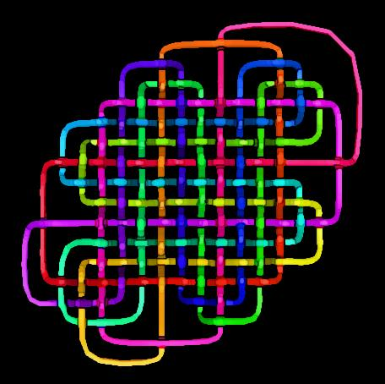
Now, coming back to our merger, when looking closer, one could see that in merging the knots, they weren’t woven in themselves anymore, which is symbolically kind of nice as they then need each other to weave together, and conversely, the merge secured the Endless Knot’s top and bottom lobes, making the whole a true knot now. Yet, I felt somehow disappointed and searched for a way to have the knots woven both together and in themselves as the originals. Eventually this could be done when using two Endless Knots for one mat ! Still not very convincing, as one could say that needing two Tibetan knots looks a bit artificial…

Figure 2: Second New, Triple Knot, with KnotPlot

Then in the lithographic studio of the RHoK in Brussels, while starting to depict on the litho stone a nice old iron lattice covering a basement, I suddenly wanted to weave some knots in it, which triggered a flashback to the unsatisfactorily solved problem above: one of the two Tibetan knots could perhaps be replaced by the lattice itself ! Unfortunately, so far, another problem occurred so doing, i.e. weaving all together, the weaving pattern of the lattice under the knots reversed… Which gives us some room for further developments ! I hope to present later some progress in this other self-imposed topological burden.

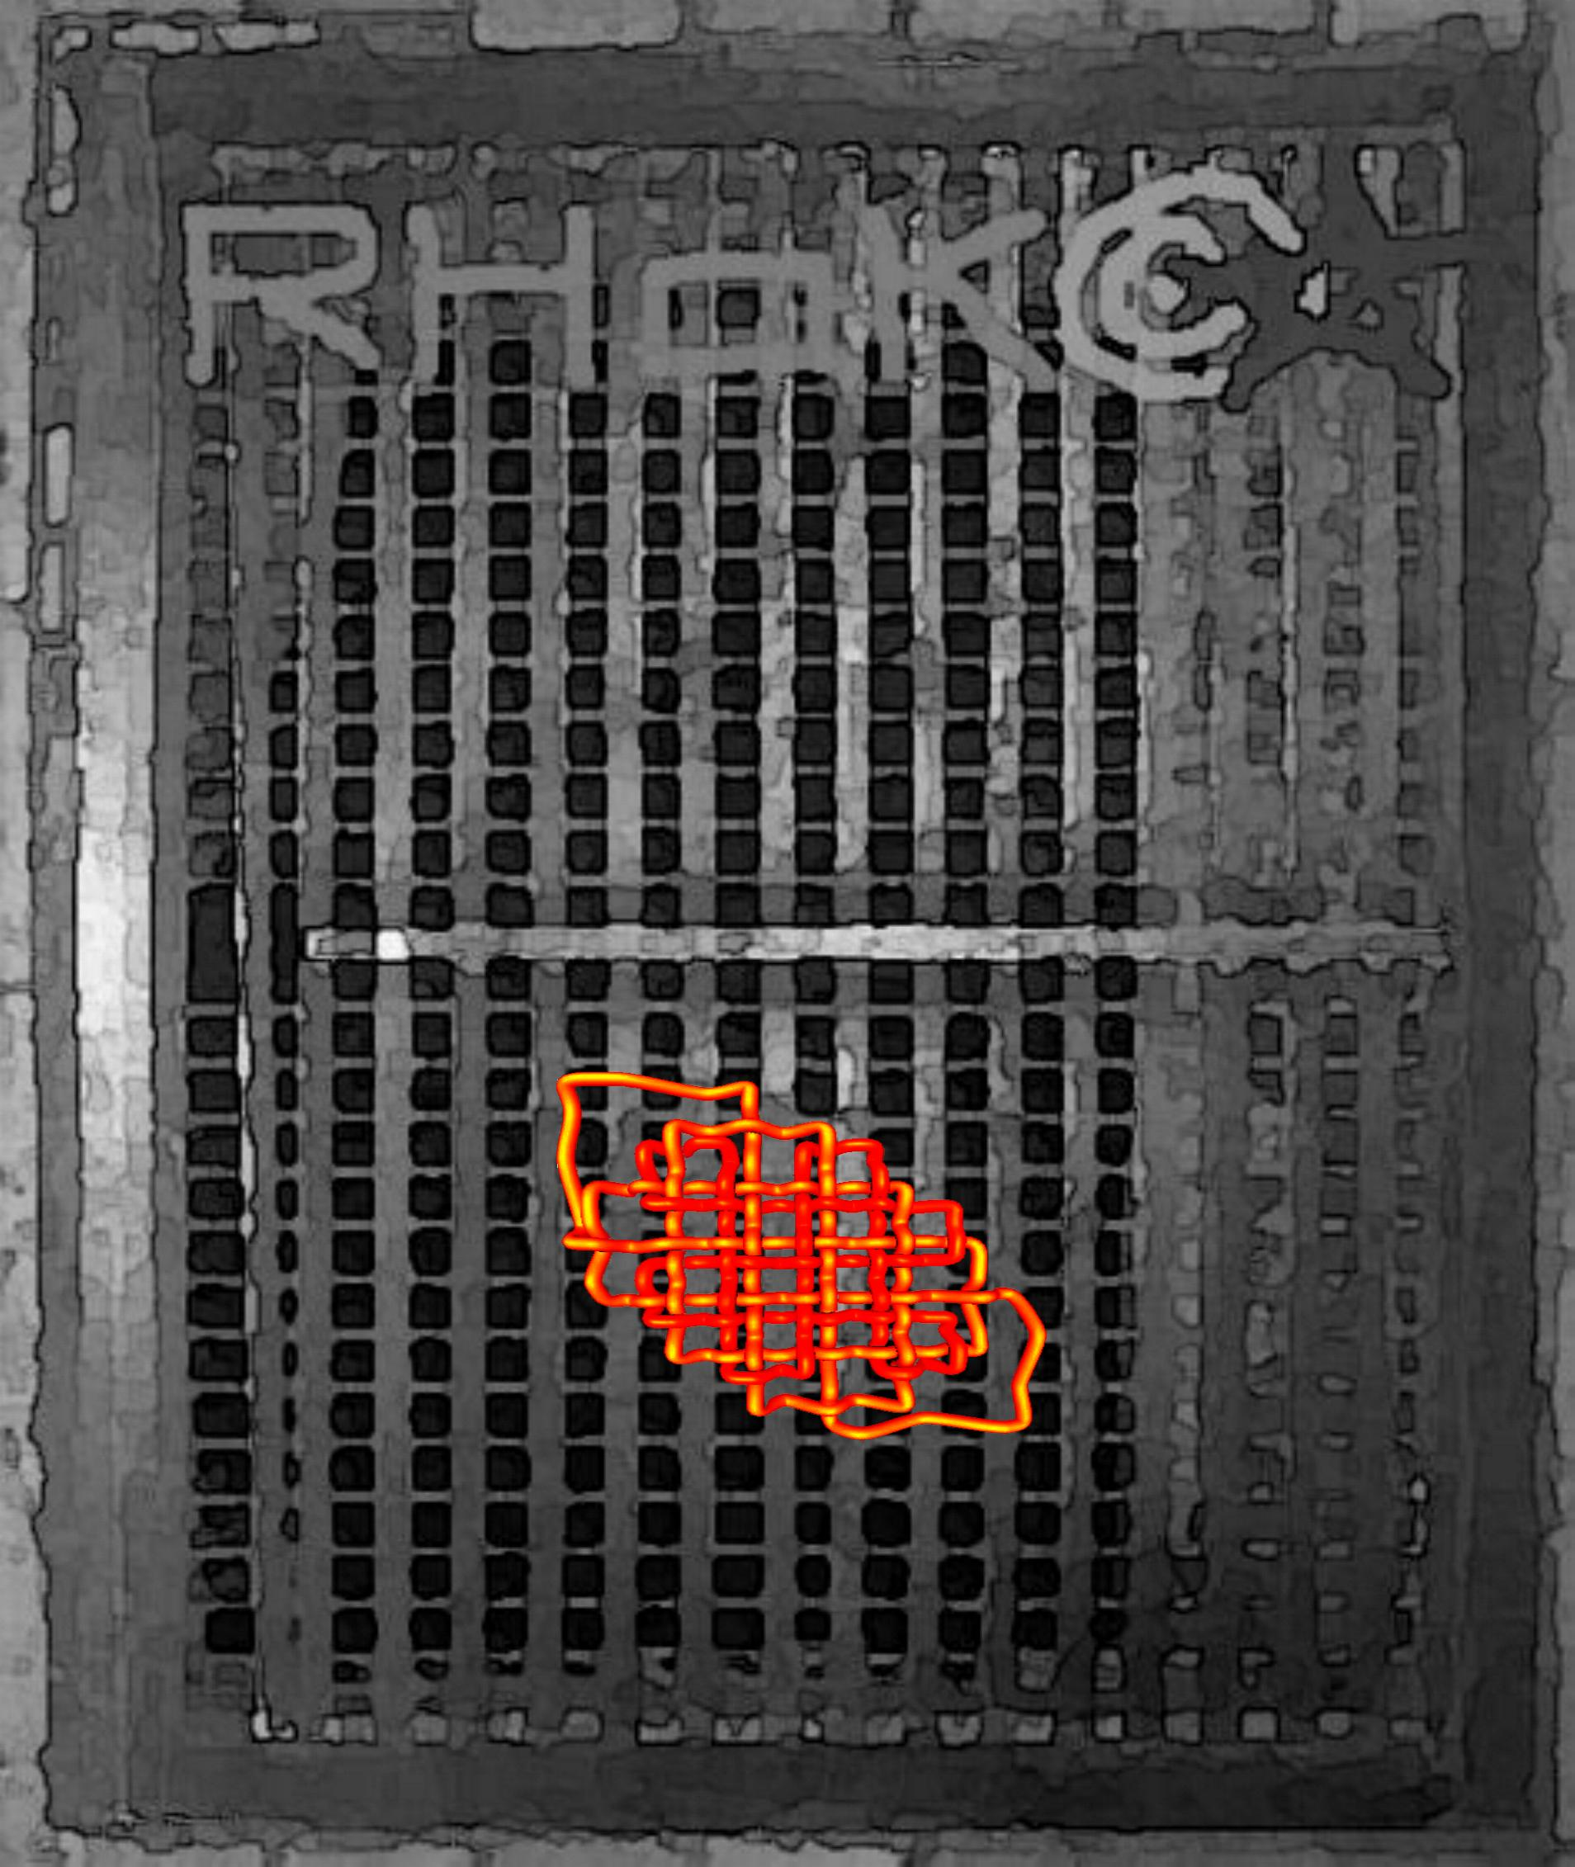

Figure 3: Third New, Double Knot, woven on RhoK lattice, project with KnotPlot

Acknowlegements

I like to thank Professor George W. Hart for having drawn my attention to this conference, Ghyacho Deurali, for accepting to sell his annotated copy of [1] in Pokhara, Nepal, Stefan Dupont and Philippe Mahieu, Belgian Marine professionals, for their kind help, Jim Keating of The Marlin Pike Sailor of Marblehead and Marc Lauwereyns, of the Belgian Branch of the International Guild of Knot Tyers, for interesting discussions. Rudolf Broulim of the RhoK, in Brussels, delightful Master Lithographer from Prague, who started with dedication my introduction in lithography precisely with this very knot ! And last but not least, at the very end, I got connection with Rob Scharein himself, father of KnotPlot which I struggled my way through, with whom I now expect a most fruitful co-operation, started to hint me further on his fabulous program.

References

[1] Jnan Bahadur Sakya, Short Description of Gods, Goddesses and Ritual Objects of Buddhism and Hinduism in Nepal, Handicraft Association of Nepal, 1998.
[2] Clifford W. Ashley, Le Grand Livre des Noeuds, Voiles/Gallimard 1998.
[3] Clifford W. Ashley, The Ashley Book of Knots, Faber & Faber 2000.
[4] http://www.pims.math.ca/knotplot/

Copyrights

All designs are protected : Copyright ©2003 by Samuel Verbiese, Sofam-Belgium. All rights reserved.
They also respect and mention the pertaining copyrights of the used software packages.
If interested, please contact me by e-mail to address : verbiese@alum.mit.edu .

Presented as part of a poster "Tangramoids, Labyrinths, Knots and other 3-D sculptures coming unexpectedly to life with KnotPlot", at joint Isama-Bridges conference 2003, Granada, Spain, July 22-25.

Samuel Verbiese
Januari 29, 2003,
revised July,21, 2003

